

Highcliffe School Student Bulletin

Monday 9th – Friday 13th June 2008: Week B

Thought For The Week:
There is no failure except in no longer trying.
Elbert Hubbard

News Topic of the Week:
Authors unhappy at age banding
‘See http://news.bbc.co.uk/cbbcnews/hi/world/default.stm


SUMMER FETE
Saturday 14th June 10:00 am – 12:00 pm
At: Highcliffe School Field
Come along and enjoy live music, beat the goalie, face painting, sponge the teacher, the china challenge, cakes, sweets, BBQ, tombola, coconut shy and much more…
Entry free! See you there!

Organisers: Please could all students make sure that they record every piece of home study they are set clearly and neatly in their organisers. It makes things so much easier when the time comes to do and to hand in home study tasks.

Examinations: There are GCE and GCSE examinations taking place in several areas of the school. During P.E., lesson change and break time please would all students remember to be very quiet around the Hall and Performance Hall areas and wherever else the 'Quiet Please' signs are displayed. Thank you.

Peer mentoring (Mrs Stone, Mrs Dedman, Mrs King):
Interviews for the role of peer mentor will be taking place this week after school. Year 9 students were invited to become peer mentors in an assembly before half term and we are very pleased to have had applications from a group of students who feel they have the qualities for such an important position.
The peer mentors will be trained to deal with a variety of issues ranging from homework and friendship problems as well as being there to listen to students on a more general basis. They will be involved on the Year 6 day in July and from September, the group will be running a variety of activities as well as being available to meet students from all years in groups or on a 1:1 basis.
This is a new and exciting development for Highcliffe School. We look forward to working with the group and we wish them well with their interviews and the training day for the selected mentors.

CSLA (Sports Leadership) - Year 12 - Moderation is on Monday 9th June P5. Please be dressed appropriately and at the minibus for 2.00pm to go to Highcliffe St Marks. Log Books & Session Plans need to be passed on to Mr Dean asap.

Year 10 Maths booster sessions start on Tuesday 3rd June: Foundation and Higher welcome. Sessions last for 3 weeks.


ECO NEWS -
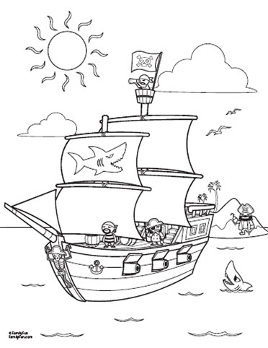
Eco club - come and be an Eco detective! (and as usual see our 6 legged friends) - Tuesday after school as usual inSc6. Finish at 4.20pm

A reminder to year 8 & 9 students involved in the Science and Engineering Group. Consent and medical forms for the RV Callista trip need to be returned to Miss High by Tuesday to secure a place.


PE NOTICES -
Results this week:
U15 rounders v Carter - won
U15 rounders v Poole High - won
Year 8 County cricket v St Puddleton - won by 40 runs
Year 7 cricket v Ringwood - won

MUSIC NOTICES -


Rehearsals for those involved in the Summer Concert.
Shout! - Monday lunchtime 1.40pm in EX3
Vocalis - Monday after school 3.30pm to 4.30pm and Wednesday lunchtime 1.40pm in EX3
Guitar Club - Tuesday lunchtime 1.40pm in EX2
Harmonious Funk Jazz Band - Wednesdays after school 3.30 - 4.30pm in EX3
Folk Band - Friday lunchtime 1.40pm in EX3

BRAINTEASER – Last week’s Brainteaser:
1. Two of the statements in this box are wrong.
2. There are 604800 seconds in a week.
3. The sum of the first 10 square numbers is 385.
4. A square is also a rectangle.
5. Multiplying a value by a whole number makes it bigger.
6. The numbers from 1 to 20 add up to 210.
Well done to the winner Cameron Dunn of 9.3 who won by explaining the solution in the following way: It’s Impossible because 5 is the only wrong answer which makes 1 wrong which makes it right!
This week’s Brainteaser:
l0l0l0=9:50
Can you make the above statement true by adding just one small line?
Answers to be submitted by Friday 20th June with name and tutor group to the brainteaser box in Ma6. Good Luck!

P.E. FIXTURES/PRACTICES

9th June – 13th June 2008

 | LUNCHTIME | AFTER SCHOOL
Monday | Year 7 Cricket | Year 7 & 8 rounders practice  Year 9 rounders v Ballard (A)  Year 8 cricket v Grange (H)
Tuesday | Year 9 Cricket | Year 10 County Cricket v Corfe Hills (H)  Year 8 cricket v Ringwood (A)  Year 9 rounders v PGS (A)
Wednesday | Year 8 Cricket | U12 rounders tournament @ BSG 2.30pm  U15 (Years 9 & 10) v Wentworth (A)  Year 9 cricket v Arnewood (H)  Cycling competition @ Grange
Thursday | Year 10 Cricket | Yr 7 & 8 rounders practice  Yr 9 rounders v Ballard (A)  Yr 8 cricket v Grange (H)
Friday | Year 10 Rock-it ball

